



Manchester, Chetham’s School
Centre Handbook
2026

Contents

Summary 3
The Centre 4
Location 5
Airport Transfers: 5
Local Amenities 6
Accommodation 6
Room Allocation 8
Housekeeping 8
Key Loss 8
Deposits 8
Meals 9
Meal times 9
Technology 9
Security 10
Safety 12
Teaching 11
Placement tests Error! Bookmark not defined.
Programme Error! Bookmark not defined.
A typical day for students 13
Manchester Chetham’s School Sample Programme - Summer 2026………….…………………………………..…..16
Facilities
Evening entertainment 16

Thank you very much for your interest in the UKLC course at Chetham’s School, Manchester. We hope you find everything you need in the following pages but if you have any questions or specific requests then please get in touch with us at Head Office on 0044 1244 577995.
The contents of this handbook are updated regularly. The latest version will be sent before your arrival.
We look forward to a successful summer 2026 at Chetham’s School.

Summary



Amazing city centre location
Short Transfers

Boarding School

Intensive English
Performing Arts

The Centre

Chetham’s School of Music is a specialist, independent, co-educational music school in Manchester city centre. The school was built in 1421 as a college for priests and became a school in 1653 and it is now the UK’s largest specialist music school.
There is extensive CCTV coverage, the houses have coded doors for access and there is a 24/7 monitored security lodge with on-site duty wardens. The security guards will do full site patrols twice a day.

There is a total of 262 beds in 3 separate houses.

In this centre we accept students from 11-17 years of age.

Location

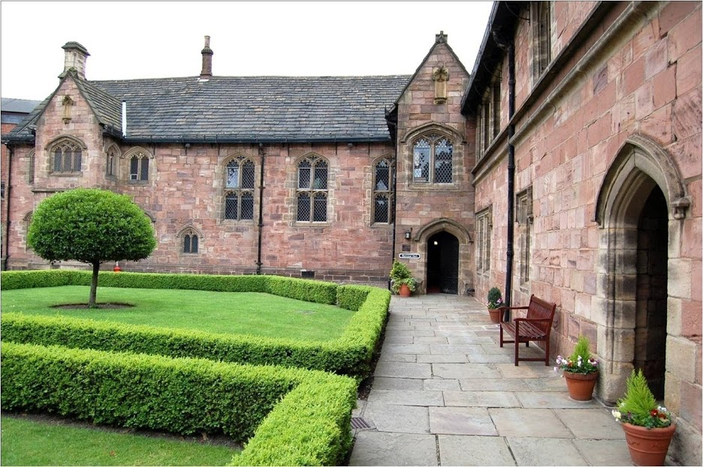

Chetham’s School of Music, Long Millgate, Manchester, M3 1SB

Telephone Number: +44 (0)161 834 9644

Population: 586,100 (2021)

The centre is right in the heart of Manchester, next to the city’s cathedral, shopping centre and museums. The campus is made up of traditional British buildings and state-of-the art modern facilities.

Famous for its industry, Manchester has been modernised over the past 20 years and has becoming one of Britain’s most important commercial and financial centres.

It is a short walk to Manchester attractions and amenities, including:
- Manchester Cathedral (0.2 miles, 4-minute walk)
- Manchester Arndale shopping centre (0.1miles, 3-minute walk)

Airport Transfers:

Manchester Airport: 30 minutes
Liverpool John Lennon Airport: 450 minutes
London Heathrow: 3 hour 5 minutes

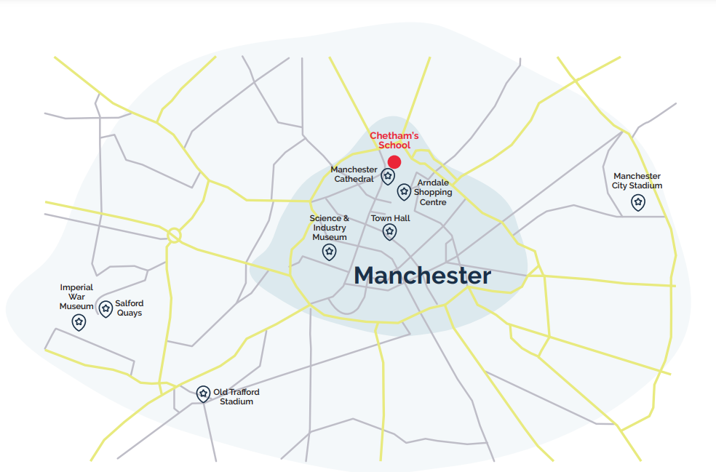
Clifton
College

Local Amenities

Post Office

Deansgate Post Office & Souvenirs Gifts

Address: 109 Deansgate, Manchester M3 2BQ (0.5 miles / 11 minutes’ walk)

ATM
Sainsbury's Bank ATM

Address: 22 Cross St, Manchester M2 7AQ (0.4 miles / 8 minutes’ walk)

Chemist

Boots Chemist

Address: Royal Exchange, Manchester, Shopping Centre, 50 Market Way, OL16 1EA (0.3 miles / 6 minutes’ walk)

Hospital

Manchester Royal Infirmary

Address: Oxford Road, Manchester, M13 9WL (3.60 miles / 15 minutes’ drive)

Doctors

City Health Centre – walk in centre

Address: Second Floor (Boots), 32 Market Street , Manchester, M1 1PL (0.3 miles / 6 minutes’ walk)
Telephone: 0161 839 6227

*N.B. If a student is ill and requires a doctor, then a Group Leader and a UKLC staff member will take the student

to the NHS medical centre at Manchester Royal Infirmary. The student will be required to fill out a temporary

patient form and will be seen on the same day.*

Dentist

City Centre Dental & Implant Clinic

Address: 31 Booth St, Manchester M2 4AF (0.6 miles / 14 minutes’ walk)
Telephone: 01618341643

Bus Stop

Turn right out of the school and they are approximately 100 meters away. There are frequent buses that run to the train station and neighbouring towns.

Train Stations

Manchester Victoria

Address: Todd Street, Manchester, M3 1WY (378 ft / 1-minute walk)

Manchester Piccadilly

Address: Manchester, M60 7RA (0.8miles / 15 minutes’ walk)

Manchester Oxford

Address: Oxford Road, Manchester, M1 6FU (1.1 miles / 22 minutes’ walk)

Taxi Companies

Street Cars: 0161 228 7878

Manchester Taxi Service: 0161 270 8701

Coffee Shops

Starbucks Coffee
Seattle-based coffeehouse chain known for its signature roasts, light bites and WiFi availability.

Address: Pleer House, 75 Fennel Street, Manchester, M4 3ES Walking distance from Chetham’s: 0.1 miles (2 minutes’ walk)

Pot Kettle Black
Situated in the beautiful Grade II Listed Barton Arcade which opened in 2014. Designed with the rich history of the building in mind, a soft industrial dining room is complemented by original oak flooring and vintage glass lighting features.
Address: Barton Arcade, Manchester, M3 2BW walking distance from Chetham’s: 0.3 miles (5 minutes’ walk)

Restaurants:

The Old Wellington

Discover a traditional pub of unique character, revered for its eclectic range of real ales and its quality pub food.

Address: 4 Cathedral Gates, Manchester, Greater Manchester, M3 1SW Walking distance from Chetham’s: 0.2 miles (3 minutes’ walk)

Hard Rock Café

Located in the centre of the city, the UK’s second largest Hard Rock Café will rock your senses serving what can only be described as “The Official Food of Rock”.

Address: The Printworks, Exchange St, Manchester, M4 2BS Walking distance from Chetham’s: 0.1 miles (3 minutes’ walk)

The Botanist

The Botanist is a concept unlike anything else, offering a selection of botanical cocktails, craft beers and ales, champagne and wine. Food inspired by the deli, rotisserie and BBQ.

Address: 78 Deansgate, Manchester, M3 2FW Walking distance from Chetham’s: 0.4 miles (9 minutes’ walk)

Accommodation

There are 3 residential blocks on-site with single, twin, triple and quad rooms. Some with en-suite and shared bathrooms facilities on the corridor. The houses are: Girls House (New College), Boys House and Victoria House.

Room Allocation
We divide the students up according to their age, gender and group where possible. We take into consideration any specific requests, i.e. friends who want to be close to each other. Group Leaders will stay in the same house as their students. Room allocation is normally done on arrival. If you would like any further information on this, please contact us.

Housekeeping
Linen is provided and are changed once a week. Towels are not provided at this centre, please bring your own., Bedrooms and bathrooms are deep cleaned twice a week. Bins are emptied and rooms checked daily; Monday- Friday.

Key Loss
If any key or key card is lost during the stay, there will be a £36 fee for a replacement. Keys for rooms are not provided at this centre (on request keys for Group Leaders may be given)

Deposits
We will ask each student for a deposit of €25/£25 on arrival. We will check their rooms before they arrive and before they leave and return the money if everything is in order. If there is damage to the houses and nobody admits fault, we will ask everyone in the house to share the cost.

Meals

When the students are on campus, they will eat their meals in the dining hall on site. When they are out on full day excursions, they will be provided with packed lunches.

Meal times
Breakfast: 08:00 – 09:00
Lunch: 12:30 - 13:30
Dinner: 18:30 - 19:30
*Mealtimes are subject to change .

If we are aware in advance, we can advise the catering staff of any dietary requirements or allergies and the canteen staff can cater to these.
Chetham’s School - Sample Menu
 | Monday | Tuesday | Wednesday | Thursday | Friday | Saturday | Sunday
Breakfast | Cereal Selection  Grilled Bacon  Scrambled Eggs  Grilled Tomato  Mushrooms  Baked Beans  Pain au Chocolat  Fresh Fruit | Cereal Selection  Sliced Ham  Sliced Cheese  Sliced Tomato  Toast & Preserves  Croissant  Fresh Fruit | Cereal Selection  Local Pork Sausages  Vegetarian Sausages  Poached Eggs  Plum Tomatoes  Baked Beans  Pain au Chocolat  Fresh Fruit | Cereal Selection  Sliced Ham  Sliced Cheese  Sliced Tomato  Toast & Preserves  Croissant  Fresh Fruit | Cereal Selection  Grilled Bacon  Scrambled Eggs  Grilled Tomato  Mushrooms  Baked Beans  Pain au Chocolat  Fresh Fruit | Cereal Selection  Sliced Ham  Sliced Cheese  Sliced Tomato  Toast & Preserves  Croissant  Fresh Fruit | Cereal Selection  Sliced Ham  Sliced Cheese  Sliced Tomato  Toast & Preserves  Croissant
Lunch | Chicken fajitas, salsa, guacamole, sour cream, coriander and lime rice, Mexican spiced vegetables (GF, DF)  ***  Firecracker quorn fajitas (VG) | Spaghetti Bolognese with garlic bread, herby mixed salad (DF, GF)  ***  Vegan Bolognese (VG,) | Beef Madras, fragrant pilau  rice, tomato and red onion salad, Indian cauliflower, naan bread, poppadum’s, dips (GF, DF)  ***  Burnt aubergine, tomato, and spinach.  (VG). | Roast turkey, roast potatoes, cauliflower, carrots. roast gravy (DF, GF)  *** | Battered cod, cod fish fingers, vegan fish fingers. peas, curry sauce, gravy, tartare sauce (VG, DF, GF)  *** | Baked tortellini formaggio, basil and tomato, garlic bread, mixed salad.  ***  Vegan pasta bake (VG) | Margherita, pepperoni or supreme veggie pizza, salt and pepper baked wedges, sprinkles and salads
Dinner | Ham, chicken and leek pie, crushed potatoes with parsley, peas and braised red cabbage  No chicken and potato pie.  (VG) | BBQ ribs, sweet and sour rainbow slaw, cheesy spring onion jackets, broccoli. charred corn on the cob  Smokey BBQ tofu ribs (VG) | Char sui pork, chow mein noodles, stir fry vegetable, prawn crackers.  Char sui quorn fillet, chow mein vegetables (VG) | Beef bourguignon, champ potatoes, peas, broccoli.  Vegan sausage bourguignon, champ potatoes, peas, broccoli  (VG) | Bang bang, chicken, prawn crackers, stir fried rice, sesame and garlic broccoli, peas.  Bang bang cauliflower, stir fried rice, sesame and garlic broccoli, peas.  (VG) | Indian spiced beef burger, dirty Madras fries, sauces, pickles, and naked slaw  Indian spiced sweet  potato burger, dirty Madras fries, sauces, pickles and naked slaw (VG) | Roast chicken, sage and onion stuffing, roast potatoes, broccoli and sliced carrots  Vegan schnitzel, sage and onion stuffing, roast potatoes, broccoli and sliced carrots (vG0
Desserts | Strawberry Cheesecake | Double Chocolate Chip Cookie | Vanilla Cake | Carrot Cake | Blondie | Chocolate and Berry Mousse | Sticky Toffee Cake

Technology

Wi-Fi is available campus wide and is password protected. Being a private boarding school, the internet access is firewalled as per the boarding school regulations. However, it is at the Group Leader’s discretion whether they give these details to their students..
There are no public phones on site. The nearest are in Manchester city centre.

Security

Emergency contacts: Each student will be given a wristband when they arrive, and this will have the following emergency telephone number printed on it: 00 44 1244 567695. If you need to contact the centre in the event of an emergency please call this number and follow the options for the relevant centre, this will then put you through to the person on duty.

Certain basic guidelines are common to all centres and students. Students should:
- Never walk away alone!
- Never leave the residence without permission in the evening!
- Always make sure they have understood when and where the meeting point is whilst
out on excursions!
- Always wear their identification lanyard and their UKLC wristband! *
*students found not wearing their lanyard or wristband will be fined £1

Safety

- Remember that there is a 24-hour emergency telephone number on the wristband (0044 1244 567695) and that the number for the emergency services (Ambulance/Police/Fire) in England is 999, or the single emergency number for the EU including the UK is 112 or you can call 101 to report a crime where you do not need an emergency response
- The police are there to help and protect and can be asked for assistance!
- Never respond to someone if you feel threatened, simply walk away!
- Always give your money to the UKLC management team to put in the safe and never to carry large amounts of cash around!
- Be careful crossing the road. Remember that in the UK we drive on the left!
- If you are ill or need a doctor, tell a member of UKLC staff immediately!
- Keep all windows closed when not in your bedrooms!

Insurance and valuables
Although all houses will be accessed via key or swipe cards, it is suggested that students try to avoid bringing very expensive items with them. If they are bringing valuables with them, it essential that they have sufficient insurance to cover any loss of damage as neither the centre nor the company can be held responsible if anything goes missing. The Centre Manager will have access to a safe if it is required.

Teaching
We know how important it is for each individual student to find their own path in language learning. We use a wide range of methods to engage and stimulate our students. This is why we have created a curriculum based on the students’ age, level and needs, structured into four different programmes:
FUN (ages 8-10)
Engaging lessons that offer a wide range of materials and activities specific for our young learners, making games into lessons and lessons into games. Available in levels A1-B1.

CONNECTION (ages 10-13)
Dynamic lessons covering a variety of topics and media, designed to engage students using tools native to the fast-paced world they are growing up in. Available in levels A1-C1.

ACTION (ages 13-16)
Lessons tailored for learners stepping into their teenage years. This programme focuses on activating students’ knowledge and competencies to balance developing a personal voice while contributing effectively to a team. Available in levels A1-C1.

PURPOSE (ages 16-18)

Lessons tailored for our students approaching adulthood, designed to kickstart their lives not only as maturing youths but also as forward-thinking global citizens. Available in levels A1-C2.

The Connection, Action, and Purpose programmes consist of three different lessons a day:

FOCUS ON LANGUAGE

These lessons aim to empower our students’ linguistic awareness and capabilities by working on all language skills (reading, writing, listening, speaking) and systems (grammar, phonology, lexis, discourse), as well as using materials relevant to exam preparation (KET, PET, FCE, CAE, TOEFL, IELTS, GESE).

FOCUS ON LEADERSHIP

This programme is designed to equip students with essential 21st-century skills, focusing on leadership development, communication and teamwork. Students build the confidence and competencies needed to grow into empowered young adults.

FOCUS ON CULTURE
These lessons combine CLIL and British culture, allowing students to use English to explore a range of disciplines, including art, literature, natural sciences, as well as the history and geography of the UK.

Placement tests
We offer classes at four levels, from elementary to advanced. Students take a placement test on their first day of classes to ensure they are placed at the correct level.

Once the tests have been marked, students won’t be told their score unless they specifically ask for it but will be placed into a class based on these results.

If students are not happy with their level, they can speak with the Course Director who will decide if it is necessary for the student to change levels.

We always try to split groups into different classes to mix nationalities, but this does depend on their levels and the numbers of students that we have on site.

We will provide all course materials including a journal and a pen.

Students are taught in class sizes up to 16.

Programme

All UKLC summer programmes include:

- 15 hours of English lessons
- Full board accommodation in residence
- Full programme of excursions, activities and evening entertainment
- 1 free leader for 15 students
- Placement test on arrival and End of Course Certificate

These are summaries of UKLC English Plus programmes** for Summer 2026 at Chetham’s School, Manchester:

English Plus Multi-Activity and City Explorer
Students take part in outdoor learning sessions around the city. They complete challenges, speak to local people, discover more about Manchester, and practise their English in real-life situations. One session per week will focus on photography or vlogging.

English Plus Performing Arts*
During these sessions, students passionate about dancing, acting, or singing will immerse themselves in hands-on training designed to unleash their creative potential on any kind of stage. They will not only develop their talents but also experience the thrill of live performance, collaboration, and artistic expression.

English Plus Intensive English & Community Building*
Additional English lessons for those who really want to maximise their language learning during their stay in the UK. Based on UKLC's integral community-building approach, these additional lessons aim to help students develop an active role in the school as a thriving community, with its challenges, complexities and opportunity for collective growth. The Community Building lessons focus on how to empower students to work together to find possible solutions to these needs and issues by communicating with people on campus. Students create these projects that they are responsible for in order to improve these issues on campus.

*Students aged between 11 and 17 who are enrolled on Multi-Activity or English Plus courses will be divided by age for activities where numbers allow. Students can choose whether to enrol on the Multi-Activity or an English Plus course.
All students aged between 8 and 10 will be automatically enrolled on the multi activity programme.

**These programmes vary at each centre. A minimum of 10 students applies to each programme and each student will be asked to select a 1st and 2nd option before arrival which they will join for the duration for their stay. Students who do not choose in advance will join the standard English Plus Multi-Activity.

A typical day for students

08:00 – 09:00 Breakfast

09:00 – 10:00 Lesson 1

10:00 – 10:15 Break

10:15 – 11:15 Lesson 2

11:15 – 11:30 Break

11:30 – 12:30 Lesson 3

12:30 – 13:30 Lunch

14:00 – 17:30 Afternoon Activities

18:30 – 19:30 Dinner

20:00 – 22:00 Evening Activities

22:00 Bedtime

Manchester Chethams School Sample Programme - Summer 2026

Week 1 |  | Morning |  | Afternoon |  | Evening
 | Tuesday | English Test |  | City Explorer or  Chosen Programme |  | Murder Mystery
 | Wednesday | Lessons |  | Manchester with Walking tour |  | Casino Night or Conversation Club
 | Thursday | Lessons |  | Vlogging or  Chosen Programme |  | Trashion Show
 | Friday | Lessons |  | Salford Quays with Imperial War Museum |  | Disco
 | Saturday | Chester with River Dee Boat Cruise |  |  |  | Attractions
 | Sunday | Free Time, Activities or Optional Excursion |  |  |  | Film Night
 | Monday | Lessons |  | City Explorer or Chosen Programme |  | Karaoke
Wee  k 2 | Tuesday | City Explorer or Chosen  Programme |  | Lessons |  | Red Vs Blue or Conversation Club
 | Wednesday | Manchester Museum |  | Lessons |  | Paparazzi
 | Thursday | Vlogging or  Chosen Programme |  | Lessons |  | Mini Olympics
 | Friday | Manchester City FC Stadium Tour |  | Lessons |  | Oscars
 | Saturday | City Explorer or Chosen  Programme | Lessons |  | Talent Show
 | Sunday | York with York Minster and the Shambles |  |  |  | Leaving Disco
 | Monday | Departures

Please note: This is a sample programme and may be subject to change. It may also be necessary to operate a zig zag programme of morning / afternoon lessons.

Evening entertainment

The UK Language Courses staff plan fantastic activities to make sure the students enjoy their evenings. For example: discos, quizzes, fashion shows, blind date, sports tournaments etc. We ask Group Leaders to encourage students to participate as much as possible and to communicate any special ideas or requests from students.

Here are a few brief descriptions of just some of our activities for students to join in on:

Around the World
Consists of a number of different stations based on activities from different countries. One staff member will be placed at each activity station. They will each represent a country and have to create an activity related to that country (for example: New Zealand – The Haka). Students will be divided into groups and given a time for each station. Students will visit each station.

Oscars Night
Involves students watching a number of scenes from selected films. They will have the chance to re-enact a famous selected scene. Creating their own script, which must be in English and costumes (out of various given equipment). Scenes will be shown on a big screen for everyone to watch. Awards will be given by UKLC staff for the best reproduction.

Speed Dating
Enables students from mixed nationalities to socialise and get to know each other whilst improving their spoken English. Students will have a short period of time to have a conversation on their interests, hobbies etc. Once the given time finishes they will move to another student and begin the same process again.

Talent Show
Gives students the opportunity to perform talents such as singing, dancing and acting in front of the whole
centre! Sign-up sheets will be available in the centre a few days before the event. There will be judges who will score the performances and give positive feedback to each student who performs on the evening.







We look forward to welcoming you to Chethams School in summer 2026!

